Overview

This document will cover using the VirtualTableTool_API excel tool. The purpose of this tool is to create an easy interface for Virtual Table specifically for API data. Due to the type of data needed (multiple lines of xpath manipulation), this tool was create separately from the UI data tool. This tool will allow you to create data for services and operations by suppling multiple “scenarios” to an operation. Only one single scenario will display on a sheet at a time, but you can open a new sheet and open a different scenario from any operation.

*NOTE* If you try to complete these steps exactly using the data as shown, you will get errors as this data already exists. These are meant to be examples of usage.

*Using the tool*

Logging in

A new requirement is the log in to the tool. A popup will appear when opening the document, requesting to enter the Lan ID. This will only occur once while the document is open, and a password is not required.

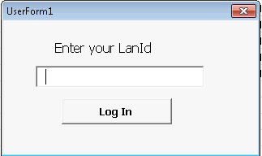

Opening the Virtual Table Tab

After opening the tool, there is a tab in the ribbon bar called “Virtual Table”, upon clicking the tab, you are presented with a number of options, many of which are grayed out.

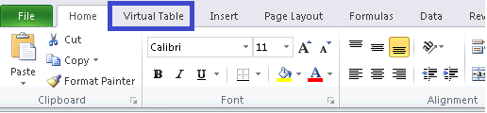

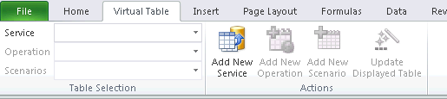

Services

At first, you will only have two options, select an existing Service, or add a new Service

1. Selecting an Existing Service
   1. Open the Service drop down list, and select the Service you want to view

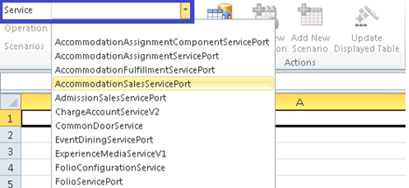

* 1. After selecting the Service (red box), it’s operations will be populated in the Operation drop-down (blue box), and the option to add a new operation will be made available (blue box).

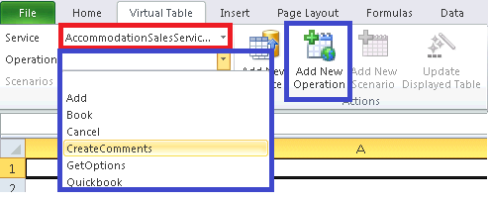

1. Add New Service
   1. If you have a Service to add that does not exist yet, click the “Add New Service” button.

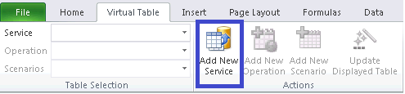

* 1. A form will appear, prompting for the name of the Service.

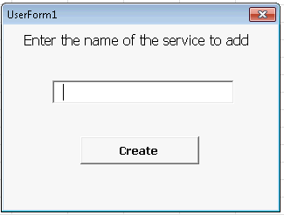

* 1. IMPORTANT: The name of the Service should match the name you give the Service in your Service class in the SITH project. This will make everything seamless and uniform.

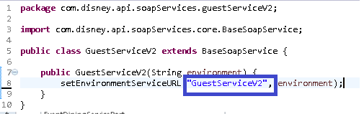

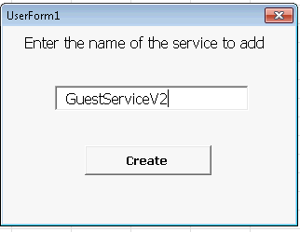

* 1. Click the Create button after entering the Service name, and the Service now appears in the Service Dropdown.

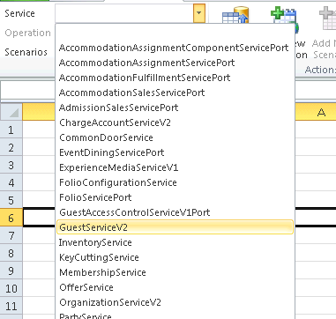

Operations

After selecting or creating a new service, the dropdown for Operations and the button to create a new operation is enabled. This document won’t go over selecting the operation as it steps mirror selecting a service.

1. Add New Operation
   1. If you have a service to add that does not exist yet, click the “Add New Service” button.

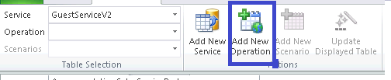

* 1. A form will appear, prompting for the name of the Service.

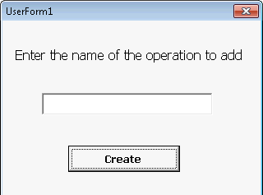

* 1. IMPORTANT: The name of the operation should match the name you give the operation in your operation class. This will make everything seamless and uniform.

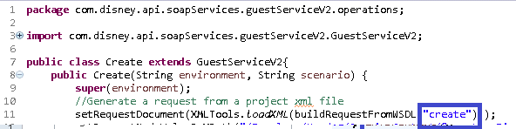

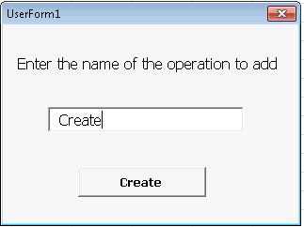

* 1. Click the Create button after entering the Operation name, and the Operation now appears in the Operation Dropdown.

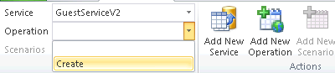

Scenarios

A given operation can have multiple scenarios, such as an AccommodationSales has book with 1 adult, 4 adults, a room only package, a dining package, etc. The scenarios created will be given names that can be referenced in the code, or from data providers.

Once you have an Operation selected, the Scenarios dropdown and Add New Scenario button become enabled.

1. Adding a new Scenario
2. Click the Add New Scenario button

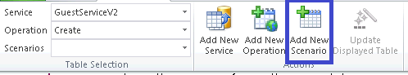

1. A form will appear, prompting for the name of the Scenario

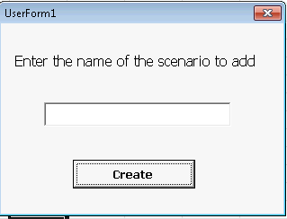

1. Enter the name of the scenario and click create. A new sheet will be created and a number with the name of the sheet will be the name.
2. \***NOTE**\* The number is an incrementer for each new sheet added or pulled down. Since it is possible for two scenarios to have the same name, this prevents duplicate sheet name errors and forcing you to close a sheet.

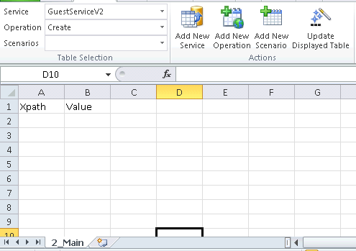

1. Columns A and B have the headers prepopulated, all that is required is to add the xpaths and the values to give them. This document will not go over retrieving Xpath info or the runtime commands that are available.

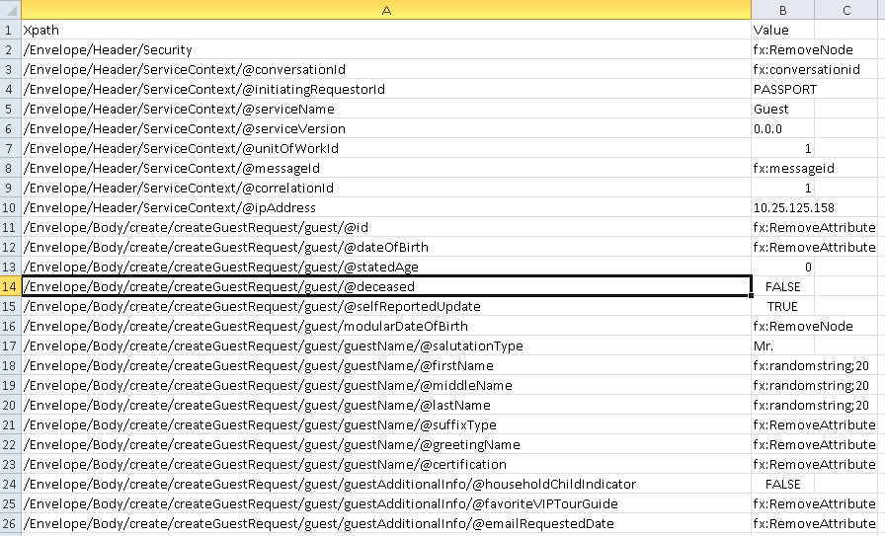

1. Once the sheet is ready, click Update Displayed Table to save the table to Virtual Tables

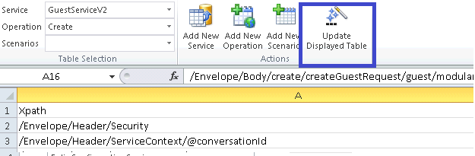

1. The scenario is now ready to be called upon in your scripts

Adding a scenario to an existing Operation

The way this is set up, all Operations are self-contained within its respected Service. Likewise, all Scenarios are self-contained within its respected Operation. If a particular scenario does not work for you, it is easy enough to make a scenario, or duplicate another scenario and modify the data we need.

For example, we will take the scenario we just made for the GuestServicesV2.Create operation. That scenario created a guest in North Carolina. We need a version that creates the guest in California.

1. (Assuming we are leaving off from previous step and the “Main” scenario is open for Create) Select GuestServiceV2 from Services dropdown and Create from Operation
2. Click Add New Scenario and name it CaliforniaGuest
3. Click back to the “Main” scenario
4. Your excel doc should now look similar to this. In blue, you just created the scenario for CaliforniaGuest. In red, the existing “Main” scenario.

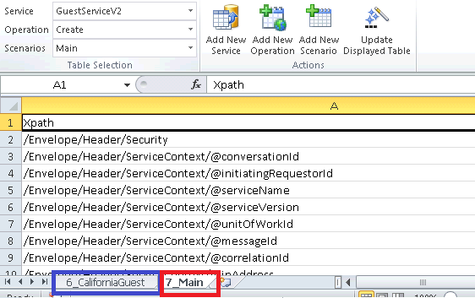

1. Copy all the data in columns A and B from the “Main” scenario, and paste them in the “CaliforniaGuest” Scenario sheet.
2. Now update the required fields to make this a California guest.

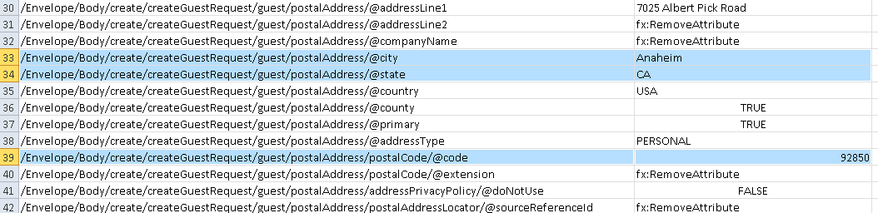

1. Now click Update Displayed Table to save your second scenario up to the Virtual Tables.

Modifying an existing scenario

**It is recommended, if you did not create the scenario, or the scenario has been in place for a time; do not modify it, simply create a new scenario. You never know what tests or teams maybe using the data available in Virtual Tables. If you modify something, it easily break things you are not aware of.**

If you are sure the data isn’t being used, and you still need to modify it; it is as simple as selecting the Scenario from the list, updating the data where needed, and click “Update Displayed Table”